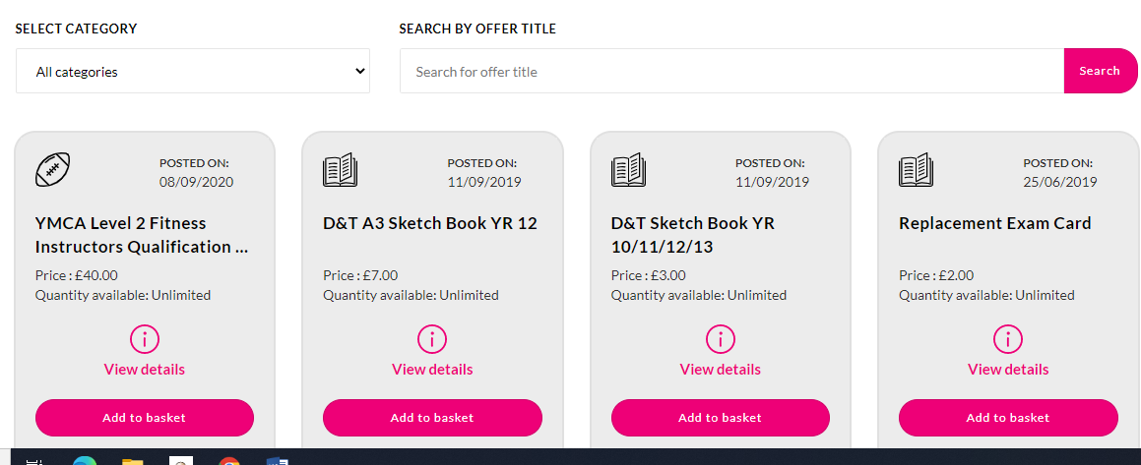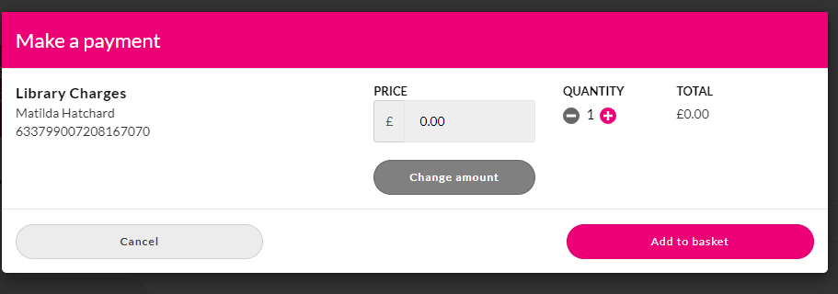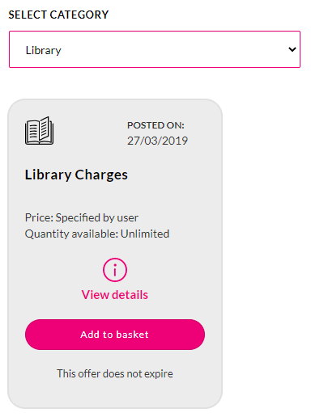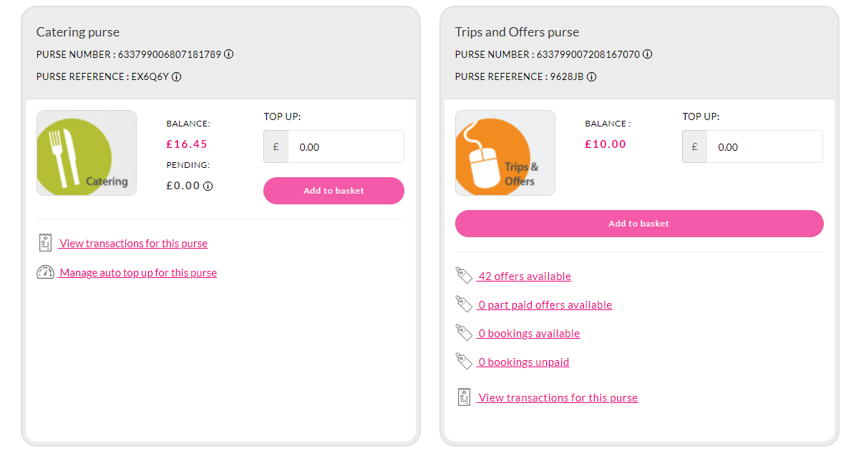

**Name: _______________________________**

**Tutor: _____**

**Book: ________________________________**

**Reason for contribution request:**

**Amount: £_____**

Guide on how to make a payment for a lost or damaged library book.

1. Log onto your Squid account.
2. Right-hand column – Trip and Offers purse
3. Click on 42 offers available
4. Select category – Library (in the drop down menu
5. Library charges
6. Click Add to basket
7. Key in the amount that has been requested by the library
8. Add to basket
9. Proceed to payment

Any problems or queries please contact the school library on 01395 255647 or email [lisa.hatchard@exmouthcollege.devon.sch.uk](mailto:lisa.hatchard@exmouthcollege.devon.sch.uk)

Thank you for your payment

Mrs L Hatchard & Mrs L Burrows