How to use Accessit – our library system

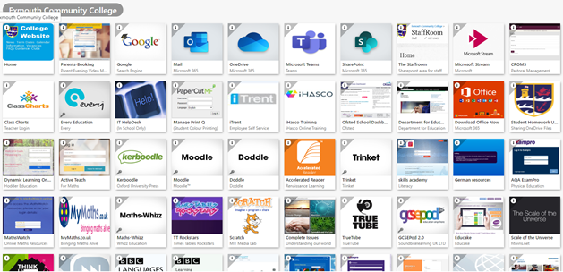

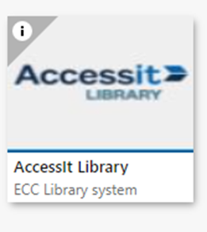

1. You will find Accessit on RMUnify

The tile looks like this

2. Click on the tile and it will bring you to this page.

3. Click blue box ‘Guest’

4. Click **Login in with school details ignore**

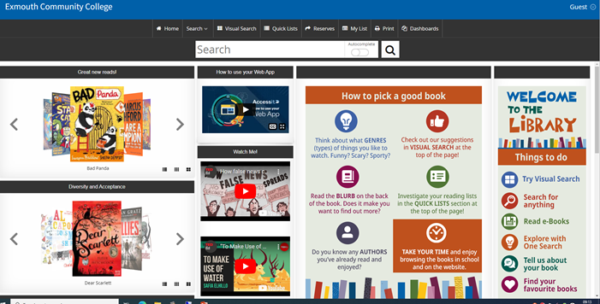

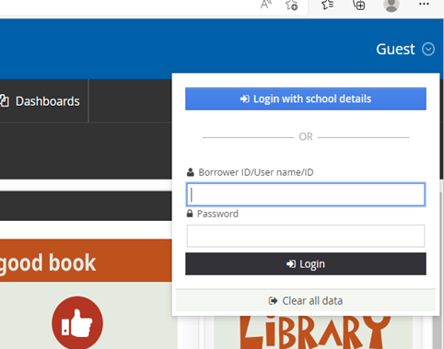

5. Log in with your school email address, no password needed

*YearFirstname.lastname@exmouthcollege.devon.sch.uk*

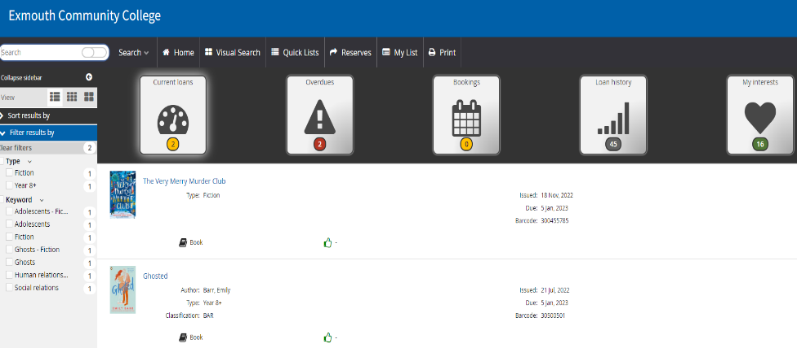

6. It will take you to your ‘**dashboard**’ where you can see the following:

* Current Loans
* Over dues
* Bookings
* Current Loan History
* My interests
* Reservations

7. On this page you can:

Renew a book – only if it’s **not** already overdue and three times in total.

Reservations – If you have a reservation it will show, you can cancel it if you no longer need it by pressing cancel.

Create your personal interest lists

See your loan history – if you click on a book in this section you can write a **book review**. One Class charts point is given for a review once checked.

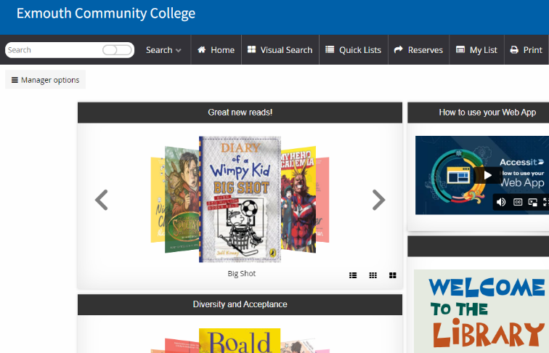

8. To search for a book press the Home icon, it will take you to this page.

Two ways to look for books:

For the following put the search in the search box at the top, you can then narrow using the on the left hand side.

* Non-fiction
* Book title
* Author

AR Books by Level

Go to Visual Search – Accelerated Reader – Select Level – This will bring up ALL the books in the level there are approximately 1500 in each level!

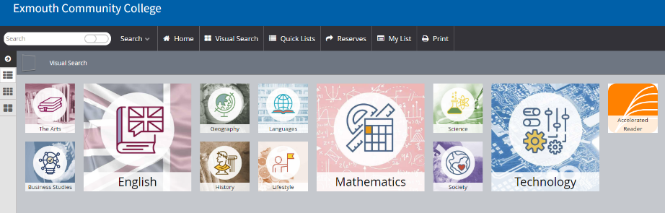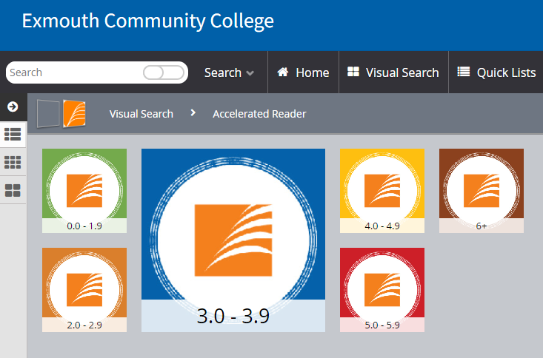

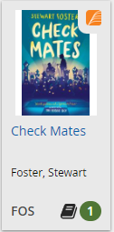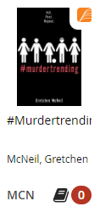

9. Tips for book search:

**Available** and in the library

**Unavailable** but click on it and you can reserve

Use the filter menu to narrow search further:

* Age category e.g. Year 10+
* Series
* Fiction/Non-fiction
* Keywords e.g. murder/dyslexic friendly

Click on the books more info:

* Blurb
* AR points
* Reserve
* Write a review
* Read reviews

How to find the book on the shelf:

Non-fiction – book have numbers on the spine 0-900

Fiction – Search by the first three letters of the author’s surname e.g. J.K. Rowling would be ROW

Books are on the shelves in alphabetical order find R and then ROW.

