HEALTH AND SOCIAL CARE – COMP 3 KNOWLEDGE ORGANISER
C2 & C3 Recommendations, support, barriers and obstacles to making changes
Recommendations and actions to improve health and wellbeing
Established recommendations for helping to improve health and wellbeing:
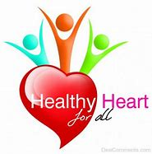
- Improving resting heart rate and recovery rate after exercise
- Improving blood pressure
- Maintaining a healthy weight
- Eating a balanced diet
- Getting enough physical activity
- Quitting smoking
- Sensible alcohol consumption
- Stopping substance misuse
Support
Support available when following recommendations to improve health and wellbeing:
- Formal support from professionals, trained volunteers, support groups and charities
- Informal support from friends, family, neighbours, community and work colleagues
Barriers and obstacles to following recommendations
The definition of a barrier is ‘something unique to the health and social care system that prevents an individual accessing a service.
Potential barriers as appropriate to the individual and the recommendation:
- Physical barriers
- Barriers to people with sensory disability
- Barriers to people with different social and cultural backgrounds
- Barriers to people that speak English as an additional language or those who have language or speech impairments
- Geographical barriers
- Resource barriers for service provider
- Financial barriers
Obstacles
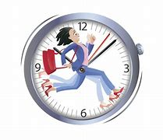
The definition of an obstacle is ‘something personal to an individual that blocks a person moving forward or when action is prevented or made difficult.’
Potential obstacles as appropriate to the individual and the recommendation:
- Emotional/psychological
- Time constraints
- Availability of resources
- Unachievable targets
- Lack of support

