HEALTH AND SOCIAL CARE – COMP 3 KNOWLEDGE ORGANISER
C1 Person Centred Approach and the Benefits
Person-centred approach to improving health and wellbeing

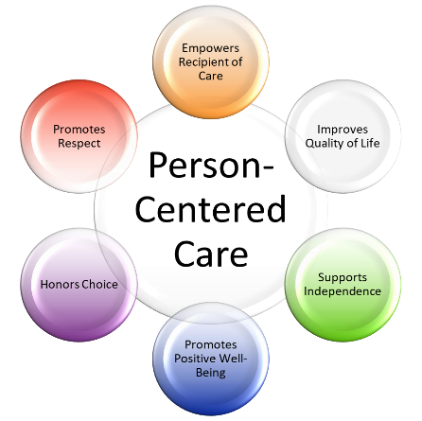
A person centred approach takes into consideration the individual’s needs, wishes and circumstances which is very important – this consists of:

- needs – to reduce health risks
- Wishes – their preferences and choices
- Circumstances – to include age, ability, location, living conditions, support, physical and emotional health

The importance of a person-centred approach
How a person-centred approach can support individuals
- Makes them more comfortable with recommendations, advice and treatment
- Gives them more confidence in recommendations, advice and treatment
- Ensures their unique and personal needs are met
- Increases the support available to more vulnerable individuals
- Improves their independence
- They are more likely to follow recommendations/actions to improve their health
- They are more motivated to behave in ways that positively benefit their health
- They feel happier and more positive about their health and wellbeing

The benefits of a person-centred approach
The benefits of a person-centred approach for health and care workers:
- Improves job satisfaction for health and social care workers
- Saves time for health and social care services
- Saves money for health and social care services
- Reduces complaints about health and social care services and workers

